**Computer Hardware**

**Class Five**

**Lab 3**

|  |
| --- |
| Lab Objectives:  * Input and Output Devices |

# Input and Output Devices

## Input and output devices allow the computer system to interact with the outside world by moving data into and out of the system. An input device is used to bring data into the system. Some input devices are:

## Keyboard

## Mouse

## Microphone

## Bar code reader

## Graphics tablet

# Keyboard

## a panel of keys that operate a computer

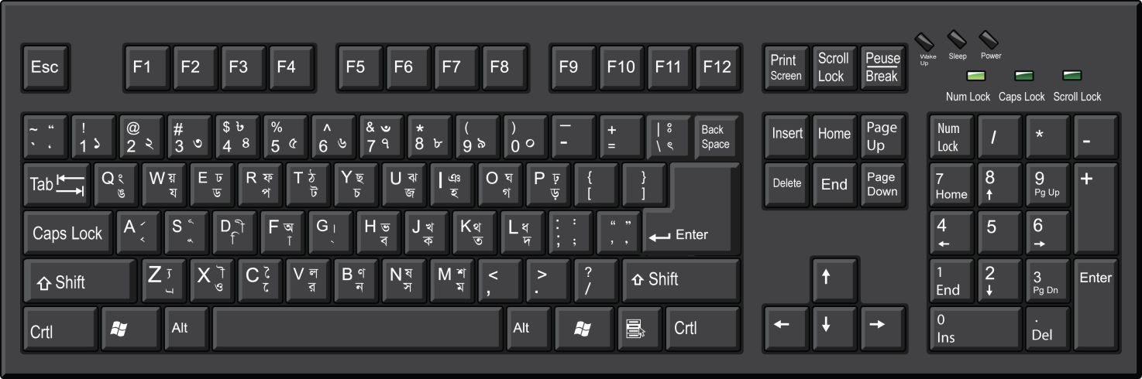

# Mouse

## A computer mouse is a hand-held pointing device that detects two-dimensional motion relative to a surface.

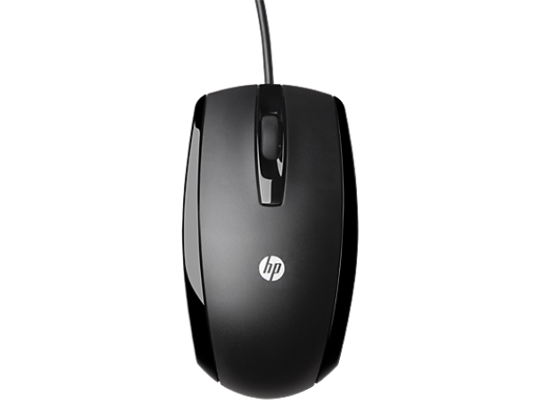

# Microphone

## A microphone is a device that captures audio by converting sound waves into an electrical signal.

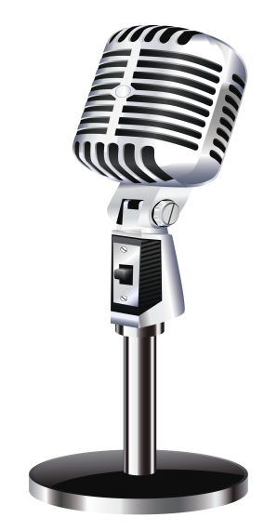

# Barcode reader

## A barcode reader, also called a price scanner or point-of-sale ( POS ) scanner, is a hand-held or stationary input device used to capture and read information contained in a bar code .

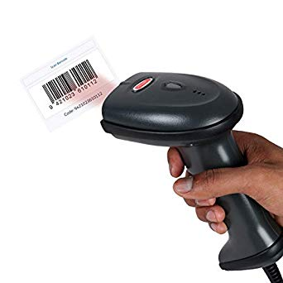

# Graphics tablet

## A graphics tablet is a computer input device that enables a user to hand-draw images, animations and graphics, with a special pen-like stylus, similar to the way a person draws images with a pencil and paper.

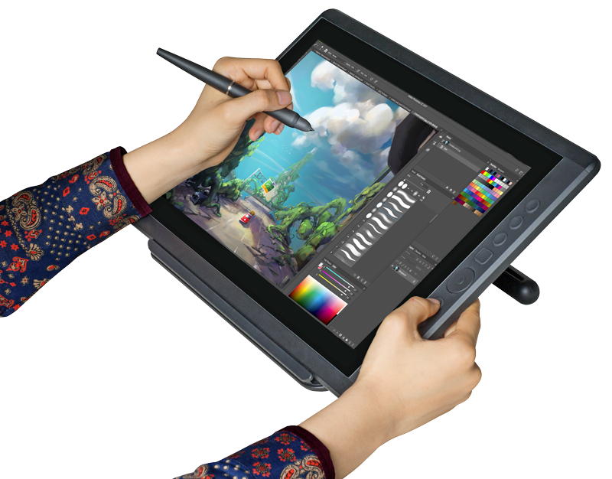

# Output Devices

## An output device is used to send data out of the system. Some output devices are:

## Monitor

## Printer

## Speaker

# Monitor

## IMG_256A computer monitor is an output device that displays information in pictorial form.

# Printer

## a printer is a device which makes a persistent representation of graphics or text on paper.

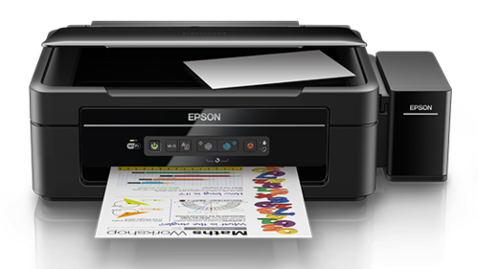

# Speaker

A computer speaker is a hardware device that connects to a computer to generate sound.

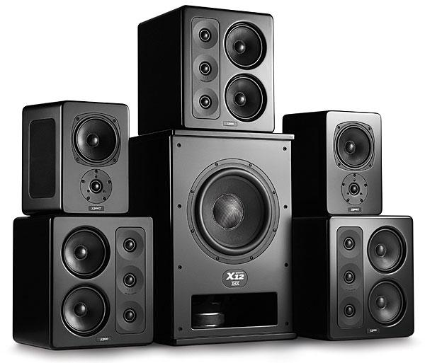

# I/O

## Input/output devices are usually called I/O devices. They are directly connected to an electronic module inside the systems unit called a device controller.

## For example, the speakers of a multimedia computer system are directly connected to a device controller called an audio card (such as a Sound blaster), which in turn is connected to the rest of the system.

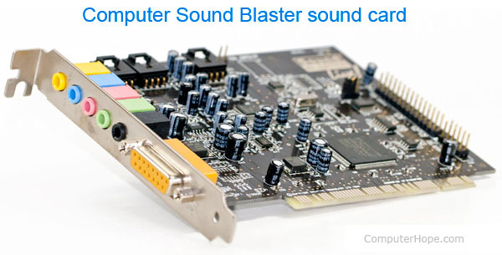

Sometimes secondary memory devices like the hard disk are called I/O devices (because they move data in and out of main memory.) What counts as an I/O device depends on context.

To a user, an I/O device is something outside of the system box. To a programmer, everything outside of the processor and main memory looks like an I/O devices. To an engineer working on the design of a processor, everything outside of the processor is an I/O device.